Agenda and Papers
Alliance Pre-Meeting
Baltimore, MD, USA
Hosted by Johns Hopkins University Center for Communication Programs
November 29th and 30th, 2017

Agenda – consideration of these papers in this order:

Background A: Consultation process to date – page 2

Background B: Intent and focus – direction from the New York All Parties meeting – page 3

Background C: Which field of work are we covering? – page 4

Background D: Working Group to commence the process – role and responsibilities – page 6

Background E: Operational principles – direction set from the New York All Parties meeting – page 7

Paper 1: Mission – page 8

Paper 2: Alliance priorities – page 9

Paper 3: Criteria for being at the table – page 13

Paper 4: 12-month plan – IMPACT DATA – page 19

Paper 5: 12-month plan – POLICY ENGAGEMENT – page 21

Paper 6: 12-month plan – INFRASTRUCTURE of the ALLIANCE – page 23

Paper 7: Name of the Alliance – page 30

Paper 8: How best to present the Alliance to the broader development community – page 32

NOTE: Please note that the text in italics in each paper is an extract from either the New York meeting report, the options paper, or the previously distributed draft implementation plan. These were important documents in the development of the Alliance. We wanted to ensure that you could easily access the relevant content from those papers relative to each of the items below in order to fully inform the decisions that will be made.

Alliance meeting
November 29th and 30th, 2017

Background A: Consultation process to date

From the New York All Parties Meeting report:

The New York All Parties meeting was part of a process aimed at discussing, exploring and making recommendations towards the establishment of a global mechanism to advance the scale and impact of communication and media for development and social and behaviour change

In the build-up to the meeting an extensive consultation process was undertaken which included meetings (face-to-face or virtual) with more than 200 practitioners, donors, researchers and academics, and government and UN agencies staff who work in this field in all regions of the world. Alongside these consultations, the CI facilitated a survey of 579 participants from 95 countries, and organized a virtual community group to discuss the mechanisms options and offer substantive feedback

In addition to these initiatives, 15 substantive contributions were received and discussed through the CI’s Soul Beat network in Africa, and 43 substantive contributions were received and discussed through the CI’s University and Higher Education network. These inputs collectively informed the development of an Options Paper that outlined a set of mechanism options and the way forward for an initial negotiation process that culminated with the stakeholders meeting.

The two-day New York meeting convened a broad range of participants (more than 60), including representatives from UN agencies, national governments, civil society organizations (CSO), academic and professional organizations, donors, and academic experts and practitioners. Most of the participants had engaged in the on-site or virtual consultations.

Alliance meeting
November 29th and 30th, 2017

Background B: Intent and focus – direction from the New York All Parties meeting

From the New York All Parties Meeting report:

Following a series of virtual and on-site consultations with more than 900 communication and development practitioners and researchers around the world, a Stakeholders Meeting was held in New York on June 27th and 28th, 2017, hosted by UNICEF in collaboration with The Communication Initiative (CI). The main purpose of the meeting was to deliberate on an Options Paper, developed with inputs from the various consultations, and to provide specific guidance on the factors required to establish an effective mechanism.

Participants supported the original intent of this initiative:

To establish a global mechanism that can help advance the scale and impact of communication and media for development and social and behaviour change.

They stressed that this mechanism should focus primarily on the role and contributions of this field to national development goals that could be organized around the priorities identified throughout the consultations and captured in the Options Paper.

Alliance meeting
November 29th and 30th, 2017

Background C: Which field of work are we covering?

From the New York All Parties Meeting report:

There was considerable discussion on the core elements, main features, and boundaries for this field of work. This is an important issue, as it defines in whose interests the mechanism will be working and which development analysis and strategies the mechanism would be seeking to advance. In an overnight poll of the meeting participants, the following were indicated (you could vote for more than one):

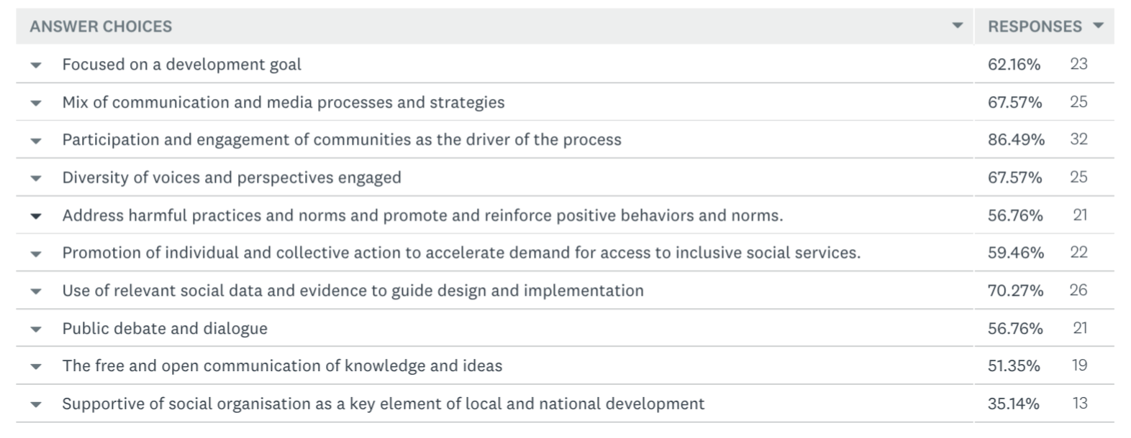

The challenge for the meeting participants was to determine how these key elements could be distilled into a clear and recognisable phrase across the various actors of this diversified field of work –and provide a clear outline of the added value and necessity of this field of work for policymakers, funders, government officials, and people in other fields of development action.

Some of the considerations included:

1. The phrase of “communication and media for development, social and behavioural change” did not curry favour. It was regarded as a catch all that provided little insight or guidance related to this work.

2. There was a strong feeling that there were some central elements that did bind this field together. In addition to those suggested in the survey above, other suggestions included: multidisciplinary; draws on many fields, including media studies, communication, anthropology, sociology, psychology, marketing, political science, and others; uses many approaches, including community mobilisation, digital media, civic engagement, media, mass media, interpersonal communication, and behavioural economics; and applies to a broad range of development issues, including health, governance, gender, humanitarian aid, and others.

3. There was discussion around the issue of scale and efficacy as opposed to rights. While communication and media for development strategies can be regarded as an important programming strategy in order to achieve development gains, it was argued that these processes can also be viewed as inalienable rights, irrespective of their connection of their role in relation to any development goals.

4. There was a desire to identify just a couple of key elements from across the broad range of segments that constitute this field of work. They all involve some form of information creation and sharing, for instance: they require engagement of people individually, in their communities, across and between countries; and there is to a greater or lesser extent the involvement of the voices of people and communities, and from gender and minority perspectives.

5. There was also a reluctance to agree on a name that was overly identified with one particular aspect of this field of work. For example, media development, communication for development, social change, behaviour change, social marketing, community participation, development communication, or programme communication. There was an overriding view that all the potential names that were raised would overly identify the planned mechanism with one component of this field, and that those sections that felt unrecognized by the name may fail to engage as a consequence.

6. There were comments on how we all perceive the development process. This has particular implications for the nature and strategy of any mechanism designed to support and advance a field of work that is rooted in people and communities. This dialogue included challenging questions and topics, such as ‘whether we all regard development as being about people coming from the North to tell people from the South what to do,’ and a stated importance for more of us working in this field to listen and learn from what happens in the South.

Alliance meeting
November 29th and 30th, 2017

Background D: Working Group to commence the process – role and responsibilities

From the New York All Parties Meeting report:

Participants (at the New York All Parties meeting) recommended the creation of an interim committee or working group that can rapidly start the process. The following participants volunteered for this task:

- Sue Goldstein - The Soul City Institute for Social Justice
- Susan Krenn - Johns Hopkins University’s Center for Communication Programs
- Patrick Cook - The International Social Marketing Association
- James Deane - BBC Media Action
- Hope Hempstone - The U.S. Agency for International Development
- Radhika Gajjala - The International Communication Association
- Lisa Hilmi - The Child Survival Resources Group
- Antje Becker - Save the Children
- Warren Feek - The Communication Initiative
- Rafael Obregon - UNICEF

The main tasks of this working group should include the following:

- Review the meeting’s discussions and recommendations and define name, structure, priorities and other relevant aspects of the mechanism.
- Develop an implementation plan for the first year of operation of the mechanism, including funding priorities, and suggest broad directions for the second year.
- This should include identification of relevant initiatives that could be easily tied to the role of this mechanism (i.e. WHO, USAID, UNICEF and other partners’ work on reporting standards on social and behaviour change and community engagement; the UNICEF, IFRC, CDAC Network and other partners’ initiative on the establishment of communication and community engagement platform within the humanitarian architecture; the upcoming Second Summit on Social and Behaviour Change Communication).
- Propose potential funding options for the operation of the mechanism and engage potential donors and partners.
- Implement a small set of strategic activities with a focus on ‘low hanging fruits” that can rapidly help position the mechanism within the larger development field. For instance, development of an advocacy/policy paper; and plan for engagement in the 2018 High Level Political Forum on the SDGs.
- Work on the formal establishment (i.e., roles and responsibilities; rules of operation, etc.) and launch of the mechanism, as well as procedures to put in place a permanent steering or advisory committee (depending on the final configuration of the mechanism) that could work for a two-year period.
- Consider other relevant activities that may help solidify establishment and operation of the mechanism.

Alliance meeting
November 29th and 30th, 2017

Background E: Operational Principles – direction set from the New York All Parties meeting

From the draft implementation plan:

In order for this process to have the best chance of working, a number of clear elements emerged from the consultations and the stakeholders’ meeting. These are reflected in the milestones and tasks outlined above. They are built from the following foundations:

Tangible focus: That the effort begins with a focus on some specific tangible steps and tasks … not on the internal development of what could be a complicated structure and process.

Working relationships: That having people from the key participants in the Alliance develop close working relationships in this beginning phase … will be more important than developing an extensive set of rules and regulations for the Alliance.

Balance between action and process: The activities and milestones outlined above … balance taking some of the actions required with building strong foundations for the Alliance.

Manageable brief: That taking these first steps with a limited number of key partnership and membership organisations as the nascent Alliance, in conjunction with the focus on a few specific areas of work … will establish much stronger roots and foundations than working to develop a full-scale process with an extensive agenda.

Early wins: There will be an emphasis on some early, substantive efforts in order to provide momentum and demonstrate added value … as opposed to a long, full-scale planning and development process.

Maintain good communication flows and relationship with the full field: That this process will not work if it is isolated from the broader global network of people and organisations working on inform and engage principles … hence the focus in each quarter on communications with that broader network.

Ownership of the strategy: It will be very important that the Alliance itself establish the programme of work within the priority parameters established through the consultation process … related to those priorities, there were lots of specific ideas proposed during the consultation and the stakeholders’ meeting (as just one example, a policy voice focus on the High-Level Political Forum). These will be fed into the Alliance for its consideration.

Stepped approach: With the approach outlined to commence with two of the priorities to start the process (impact data and policy voice) followed by a delayed start to the other two priorities (funding and standards), a manageable process is further outlined.

Alliance meeting
November 29th and 30th, 2017

Paper 1: Overall Mission

Proposed:

Below are some options to emerge from the consultations process. We may need to keep coming back to this issue with ideas and refinements as we move through the other agenda items.

“Restore people to the center of development thinking and action”

“Advance the scale, impact and standards of communication for development, media for development, social change and behavioural change action.”

“Fully informed and actively engaged societies on their priority issues in their contexts”

“Working to ensure that development policies and practices are strongly influenced by the realities of development action”

Alliance meeting
November 29th and 30th, 2017

Paper 2: Alliance priorities

Task: Endorse the initial priorities for the Alliance over the next 12 months

Priorities Group input

The priorities group decided on the following priorities:

A. Build the infrastructure of the Global Alliance – articulate terms of reference, determine participation criteria, convene initial meetings, communicate the initiation of the Alliance, and lay all of the other foundations required for the successful commencement of the Alliance.

B. Commence the work related to best impact data – landscape the most compelling evidence and its strategic implications.

C. Focus on one major advocacy initiative for this field of work. There was strong, unanimous support in the meeting for that work to be focused on the next meeting of the High Level Political Forum (HLPF). The theme for their July 2018 meeting is "Transformation towards sustainable and resilient societies".

Background: From the New York All Parties Meeting report:

(Note – the missing numbers are because those points were specific to one of the priorities – e.g., impact data - so they have been included there.)

Framed by the possibilities outlined in the Options paper, participants spent considerable time debating the highest priorities to be the focus for the planned mechanism – meaning the specific problems that the mechanism would seek to address.

These also formed a question for the overnight survey. The results follow. Please note: the key column is “weighted average”, and the closer to zero, the higher the priority.

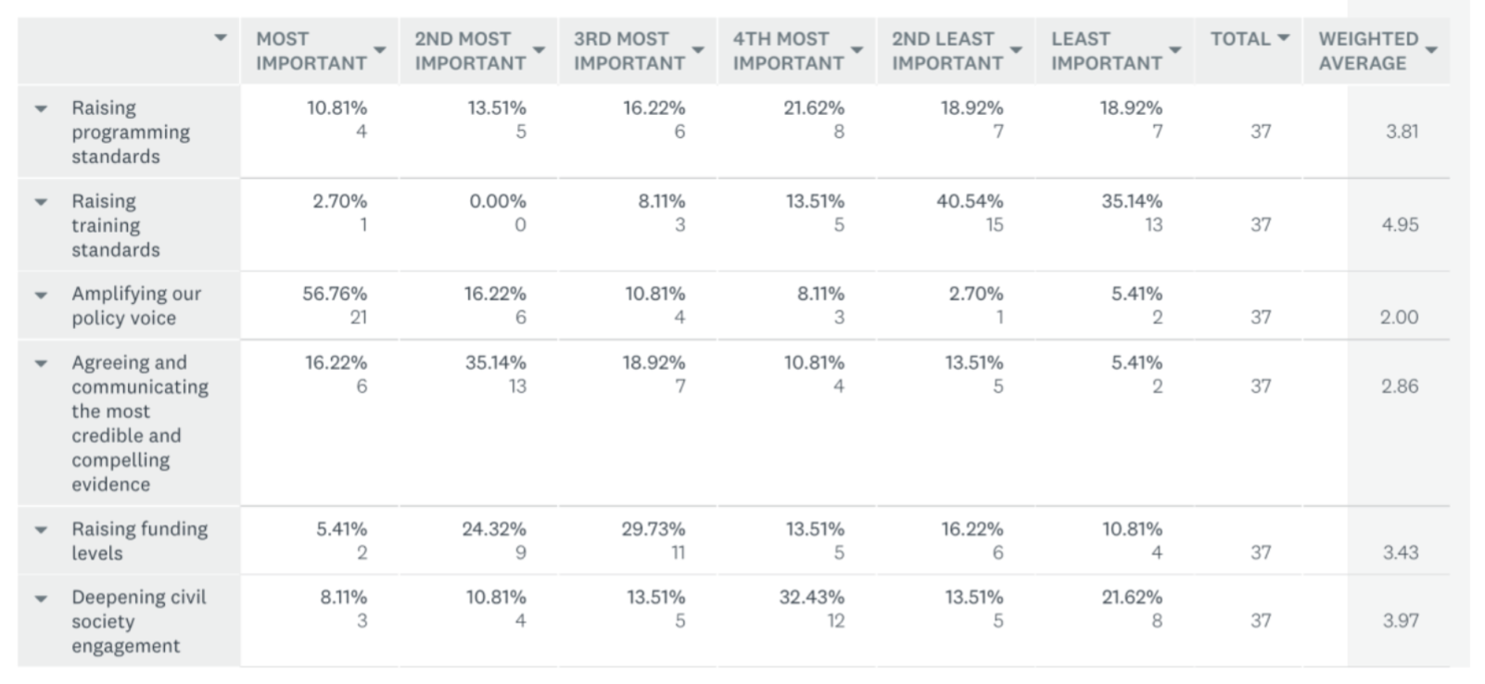

In priority order, the participants rated the following:

1st – Amplifying our policy voice

2nd – Agreeing and communicating the most credible and compelling evidence

3rd – Raising funding levels

4th – Raising programming standards

5th – Deepening civil society engagement

6th –Raising training standards

Allied to these priorities there was strategic guidance concerning the manner in which they should be implemented, including:

1. The need for some quick, reasonably simple tasks that can be completed in order to generate momentum around the highest priorities – for example, it was suggested that an initial focus could be placed on generating a top 10 impact data list with the extraction and compilation of the key data results.

3. The importance of avoiding duplication vis-à-vis other initiatives whose focus may be
to provide opportunities for synergies (i.e. the WHO, USAID, UNICEF and other partners’ work on reporting standards on social and behaviour change and community engagement interventions for maternal, child and adolescent health; the UNICEF, IFRC, CDAC Network and other partners’ initiative on the establishment of a Communication and Community Engagement Platform within the Humanitarian architecture).

4. Whilst some felt comfortable with a global fund being created for this field of work, it was made clear that most participants would not support the creation of such a global fund.

5. There was broad support for increased action to raise the overall levels of funding available for communication and media development, social and behavioural change action. Strong mention was made of the need to provide support and guidance to Southern organisations to raise the funds they require.

6. Some participants stressed the relationship between policy voice, evidence, and funding, and asserted that positive action on these is interrelated and do not stand alone.

7. There was a strong view from some participants that the civil society component needed to be rearticulated and strengthened –that it was missing.

8. Questions were raised concerning the desirability of linking the priorities to the SDGs and/or placing the overall initiative in the context of the SDGs. From one perspective, this would provide a base for the mechanism that directly related to a major global priority setting process. Others were of a view that the SDGs did not yet have the traction and standing required at national and local levels, however, and so the link to national and local development plans would be more appropriate and relevant. From the later perspective, there was a view that operating within the rubric of the SDGs could help with the funding goals.

9. As the SDGs are extremely broad, with 17 goals and 169 targets (some of which do not have numeric-based indicators), there was a suggestion that the mechanism could focus on one part of the SDGs – for example, those related to freedom of information.

11. The issue of timeframes gained considerable traction in the course of the meeting. There is concern that in working on very complex and embedded behaviours, social norms, cultural expressions, etc, there is very little possibility of making the substantial shifts required in the course of the 3, 4 or 5-year timeframe that is standard for the funding of most programme initiatives. Strong suggestions were made that this timeframe issue should be a substantial policy point in the work of the mechanism.

14. Across all priorities, the common issue of “packaging” and uptake of evidence and standards was raised and discussed. When it comes to questions of policy, funding, evidence, the other priorities, there was a clear expectation that the mechanism would significantly improve the presentation of this field of work.

15. A number of comments were made related to Southern perspectives and interests across these priorities – for example: how to obtain funding for indigenous organisations that grow up from local people with a huge understanding of local context but who have to compete with major international organisations for funds; the complexities of ensuring that funding flows to the municipal level; and the variations in regional trends in priorities, challenges, and needs.

16. The focus of the above priorities included references across all elements of development action, including: democratic governance, child rights, humanitarian action, pandemics such as Ebola, health, the “Grand Bargain”, children, rights, environment, violence against women, female genital mutilation (FGM), maternal mortality, sexual and reproductive health, education, water and sanitation, polio, conflict and emergency situations, gender, adolescence and youth, and many more development issues.

From the draft implementation plan:

C. Priorities

To strengthen government, international agency, and civil society communication action towards fully informed and actively engaged societies through a focus on:

a. Impact: Identifying the most compelling and credible research and evaluation data that (i) demonstrates the development impact of strategies rooted in inform and engage principles and (ii) identifies strategic principles for more effective action across a larger number of societies.

b. Policy: Working to ensure that the analysis, experience, perspective, and ideas of people and organisations working to inform and engage strategic principles are prominent in national and international development policy fora.

c. Funding: Expanding the funding possibilities for organisations working to inform and engage strategic principles.

Alliance meeting
November 29th and 30th, 2017

Paper 3: Criteria for being at the table

Tasks:

- Decide which organisations will comprise the inaugural version of the Alliance.

Criteria Group input

The Criteria Group developed the following process for agreeing who would be at the Alliance table:

- Identify the major “pillars” of this field – proposed are the following:

- Behaviour change
- Social change
- Media for development
- Communication for development
- Community engagement and action
- Social marketing
- Social networks
- Social justice
- Research
- Policy development
- Funding

Of course these overlap. They are not distinct and discrete. But they do provide a way to identify the pillars of this field.

- For each of those pillars, identify the following as the basis for commencing the Alliance:

- One partnership-, network-, or membership-based organisation
- One leading organisation related to that pillar

Examples: (please note that these are not proposals; they are just examples to indicate how the Alliance may be comprised, including some possible gaps – have not covered every organisation, just some of them as examples)

Research: ICA and Uninorte (Colombia)

Social justice: CIVICUS and Soul City

Media for development: Global Forum for Media Development (GFMD) and BBC Media Action

Social marketing: International Social Marketing Association (ISMA) and PSI

Communication for development: C4D network and UNICEF

Community engagement and action: Global Voices and East Africa Community Media Network (EACOMNET)

Behaviour change: International Union for Health Promotion and Education (IUHPE) and Johns Hopkins University Center for Communication Programs

Funders: The nascent media development donors network and The Bill and Melinda Gates Foundation

Social Change: Our Media Network and Puntos Encuentro

- Based on the criteria agreed in relation to above:

Decision: Which networks, partnerships, associations, and organisations will be invited to form the inaugural Alliance?

As a starting point, the following were suggested in the New York meeting:

“Build the core alliance through the gathering and facilitation of a group that includes the two most senior people (e.g., Chair of the Board and most senior staff person) for membership- and/or partner-based organisations that seek to bring segments of this field of work together.

Potential members of that initial group would include organisations such as (where applicable, key contacts are listed):

- UN agencies (with the limited role of the Communication for Development Roundtable, a new UN coordination mechanism will need to be established) – to commence, UNICEF as the interim inaugural Chair of this Alliance
- Member States (key ministries) – Potential candidates could be ministries of health that have invested in this area of work (e.g., Egypt’s Ministry of Family Planning and Welfare)
- Global Forum for Media Development (GFMD) - Ricardo Corredor, Chair of the Board; Mira Milosevic, Executive Director
- International Union for Health Promotion and Education (IUHPE) - Graham Robertson, President; Erma Manoncourt, Vice President for Membership
- Africa Media Initiative - Trevor Ncube, Board Chairman; Eric Chinje, CEO
- International Association for Media and Communication Research (IAMCR) - Janet Wasko, President; Gerard Goggin, Secretary General
- International Communication Association - Paula Gardner, President; Radhika Gajjala, focal point
- African Women’s Development and Communication Network - Emma Kaliya, Chair; Dinah Musindarwezo, Executive Director
- International Social Marketing Association - Patrick Cook – President; R. Craig Lefebvre, Past Vice President and Chair, Fundraising Committee
- Communication for Development Network – Stacy Hilliard, Chair of the Board; Jackie Davies, Director
- Our Media Network – Amparo Cadavid, present convenor
- Communicating with Disaster Affected Communities partnership (CDAC) - Brendan Gormley, Chair; Marian Casey-Maslen, Director
- The ICT4D Conference and Network – Schulyer Thorup, Chair
- CIVICUS - Anabel Cruz, Board Chair and Chair of the Executive Committee (Instituto de Comunicación y Desarrollo); Dr. Dhananjayan Sriskandarajah, Secretary General.”

Full background from the New York All Parties Meeting report:

The structural base for the mechanism will need to support the overall goals and priorities being pursued. Following the consideration of the principles and priorities described above, the meeting moved to a consideration of the best general structure for the mechanism.

The discussion was framed by the Options paper, which outlined the 3 major possibilities to emerge from the extensive consultations prior to the all interested parties meeting. On this question, the overnight survey produced the following results:
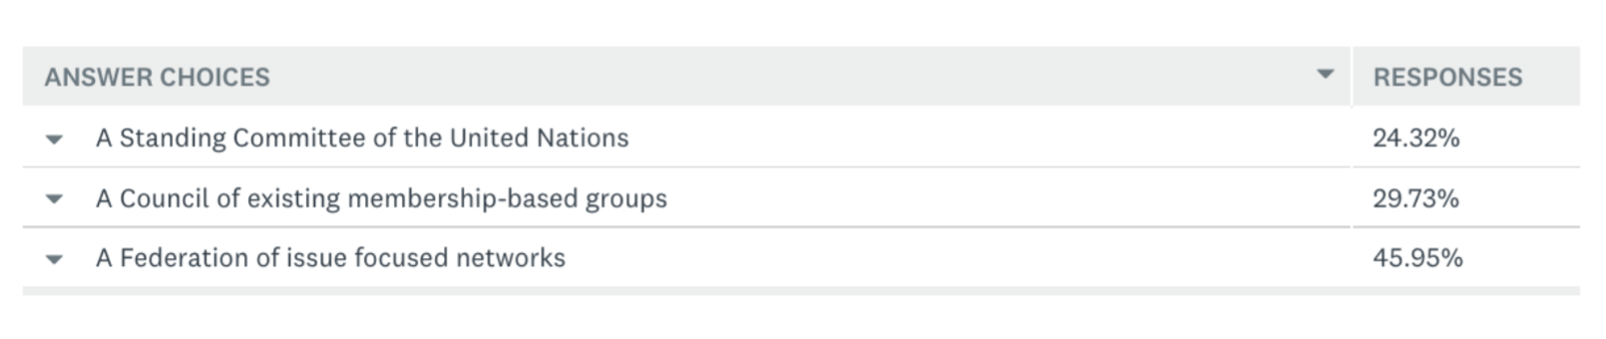

When asked to choose just one option, participants in the meeting preferred

“A Federation of issue focused networks”.

This arrangement involves, as outlined in the Options paper, the field performing a support and coordination role for the range of issue-based networks that present the voices and perspectives of people directly affected by development issues – from people living with HIV/AIDS to those engaged in environmental action. In the discussion that followed the revealing of these overnight results, however, most of the participants raised how difficult it was to choose just one of the options provided by the survey. As a result, a more nuanced position was proposed to reflect a strong preference among the participants for a structural base that would allow and support all 3 options. It was also recognised that:

1. It is important to start with a base in our field of work – those with a vested interest.

2. The approach chosen should both enhance and support existing mechanisms related to particular segments of this field of work – for example, those engaged in social marketing.

3. There should not be competition between the new mechanism and existing processes related to parts of this field – for example, the Communication for Development Network (C4D Network).

4. There needs to be the possibility of organically growing the structural base for this mechanism to encompass all 3 of the elements that were presented as separate options – an official UN relationship; a Council of existing membership-based groups; and a Federation of issue-focused networks.

5. The mechanism should work from the perspective of being able to clearly demonstrate to its
stakeholders that they are receiving a distinct benefit from the work that is taking place. Without
that ongoing demonstration, there is little likelihood that both commitment to and identification
with the mechanism developed will be sustained.

6. Specifically related to the Standing Committee of the UN, some of the possible benefits raised included: the value of embedding this mechanism at the governmental level, which could be important for action in-country as UN representatives seek guidance from their capitals, thus engaging relevant country actors; a possible direct line to major global agencies such as WHO, UNICEF, World Bank, UNDP, FAO, and others; the likely requirement that there would be regular reviews that provide a structure to advance this work; and that such a mechanism would provide direct support to the units and people within those UN agencies that are active on communication and media for development, social and behavioural change.

7. Some problematic aspects of a UN Standing Committee structure were also raised, including: being embedded in a comparatively slow and cumbersome bureaucracy; the difficulty of having strong civil society processes within the UN system given that it is an inter-governmental organisation; the requirement for some form of independence; and that one of the most problematic parts of our field of work is within governments, which have in most cases been very slow to adopt effective, at-scale communication and media development, social and behavioural change strategies.

8. There was general agreement around the positive aspects of a Council of existing membership-
based groups as the basis for the mechanism. For instance, some of these points included: there are a significant number of such groups that can be the basis for the initial Council; it avoids any possibility of competing with those partnerships and networks; they share the issues and priorities as identified for the mechanism; it could be a flexible process that can react nimbly and quickly to requirements as the mechanism evolves; there would be accountability through the memberships of those membership-based organisations; it provides a base from which to grow both the numbers of membership-based groups involved; and this approach is one that this field itself could initiate and grow – we would not be dependent on others.

9. Meeting participants also raised, however, that the Council of membership-based groups approach does come with some difficult aspects, including: that these partnerships and networks are mostly based in the North and led by people from those contexts; that they are not in of
themselves resource rich so would not be contributing funders of such a process; and that the
existing mechanisms may cover neither all strategic elements of this field – for example, entertainment-education – nor all development issues – for example, environmental-focused work.

10. As highlighted above, the overnight survey preference was for a mechanism based around the
concept of a Federation of issue-focused networks. Some of the arguments in favour included that: many of these have strong Southern leadership –for example, related to HIV/AIDS, the environment, democracy movements, and/or rights based movements; they provide an accountability process through their membership direct to the people experiencing and active on the priority development issues; the communication and media for development, social and behavioural community would gain considerable weight from such relationships; and it would ground the policy, voice, impact, and standards work in very relevant experiences and analysis.

11. As with the other options, there was a downside expressed: Such a process may take a long time to develop; it would require a very active process to cultivate the relationships required; the issue-based networks would need to see clearly the added benefit for them from such a relationship; such groups are likely, by their very nature, to be critical of government, UN, and other major agencies, which could produce excitement but also a risk; and it may prove difficult to be the secretariat to such a Federation when we have our own priorities to pursue.

Background: from the draft Implementation plan:

Key Action Points for the First 12 Months:

a. Build the core alliance through the gathering and facilitation of a group that includes the two most senior people (e.g., Chair of the Board and most senior staff person) for membership and/or partner-based organisations that seek to bring segments of this field of work together.

Potential members of that initial group would include organizations such as (where applicable key contacts are listed):

- UN agencies (with the limited role of the Communication for Development Roundtable, a new UN coordination mechanism will need to be established) – to commence, UNICEF as the interim inaugural Chair of this Alliance
- Member States (Key ministries) – Potential candidates could be ministries of health that have invested in this area of work (i.e. Egypt’s Ministry of Family Planning and Welfare)
- Global Forum for Media Development (GFMD) - Ricardo Corredor, Chair of the Board; Mira Milosevic, Executive Director
- International Union for Health Promotion and Education (IUHPE) - Graham Robertson, President; Erma Manoncourt, Vice President for Membership
- Africa Media Initiative - Trevor Ncube - Board Chairman; Eric Chinje – CEO
- International Association for Media and Communication Research (IAMCR) - Janet Wasko, President; Gerard Goggin, Secretary General
- International Communication Association - Paula Gardner (President), Radhika Gajjala (focal point)
- African Women’s Development and Communication Network - Emma Kaliya - Chair; Dinah Musindarwezo - Executive Director
- International Social Marketing Association - Patrick Cook – President; R. Craig Lefebvre - Past Vice President and Chair, Fundraising Committee
- Communication for Development Network – Stacy Hilliard, Chair of the Board; Jackie Davies – Director
- Our Media Network – Amparo Cadavid (present convenor)
- Communicating with Disaster Affected Communities partnership (CDAC) - Brendan Gormley, Chair; Marian Casey-Maslen, Director
- The ICT4D Conference and Network – Schulyer Thorup (Chair)
- CIVICUS - Anabel Cruz - Board Chair and Chair of the Executive Committee (Instituto de Comunicación y Desarrollo); Dr. Dhananjayan Sriskandarajah - Secretary General.

There may be others to be added, particularly individual organizations such as donors and government officials unless they are members of partners based organizations. As this process evolves, it may help to motivate other parts of this field of work to get organised – for example, the entertainment-education community. This group will need to be facilitated and supported in their work by an agreed Secretariat (initially one to handle the start-up phase).

Explanation:

As an initial step, this matches one of the 3 options – the Council idea – for the basis of the mechanism in the consultations and the stakeholders’ meeting. The other 2 options (UN relationship and civil society networks) will follow to build the hybrid model that was requested as the favoured mechanism model by participants in the stakeholders’ meeting.

It will be very important for this process to commence in a manageable way - starting small with good cohesion and moving from there.

These are the core membership- and partnership-based organisations that cut across the “inform and engage” field of work (subject to others being added – in particular, regional organisations).
They meet the criteria being applied – a membership or partnership base. They are not discrete programming and/or policy organisations.

Key Action Points for the Second 12 Months:

From the base established:

- Reach out to and engage civil society networks to join this process as outlined in Option 3 of the Options paper.
- Identify and establish the credentials for an appropriate UN relationship. This would not be the Standing Committee as outlined in Option 1 of the Options paper; it would be a specific relationship to a particular committee of event such as the High Level Political Forum, ECOSOC, or existing special commissions.

Explanation:

This is left more general than is outlined for the first 12 months. As will be seen from the main activities and milestones outlined below, judgments will need to be made related to the best options for both the civil society and UN relationships. For example, it could be that the next steps for both of those are determined by the decisions related to the impact, policy, and standards priorities.

Should a decision be made to test the process with a focus on a particular issue then the possibilities could include: the reviews being undertaken by the Committee on the Rights of the Child, any reviews being undertaken by UNAIDS related to HIV/AIDS strategies, engaging the World Bank on its next World Development report, engaging the Gates Foundation concerning its focus on this field, or any other option that could inform the nature of either the civil society networks and partnerships from the South and/or the point of engagement with the UN system.

Alliance meeting
November 29th and 30th, 2017

Paper 4: 12-month plan – IMPACT DATA

The following is proposed for your consideration:

Goal:

To identify and agree upon the 20 most compelling (results, methodology, and journal published) research that draws a direct connection between a communication, media, social and/or behaviour change strategy, programme, or social trend, and positive movement related to one or more SDGs in local, national, or global contexts.

Products:

- A peer-reviewed journal article on the above theme that has been submitted to a leading and relevant journal.
- A 2-page distillation of the results with the most compelling data.
- A 4-page outline of the strategic implications from that data.

Supporting this field of work:

- Organise extensive communication of the 2-page distillation and 4-page strategic outline through all major networks relevant to this field of work.
- Prepare for communication of the peer-reviewed journal article when published.

Responsibility:

A small action group to pursue this goal and develop these products with updates on progress and issues reported to meetings of the Alliance.

Proposed: Communication for Development Network, Our Media Network, African Women’s Development and Communication Network, International Social Marketing Association, Soul City Institute for Social Justice, ICA, Johns Hopkins University Center for Communication Programs, Uninorte, Los Baños University.

The group would select their own Chair. Interim Secretariat support would come from The Communication Initiative.

Commitment: One staff person for one day a week over the 12-month period of this task.

Background: Relevant extracts from the New York report and the draft Implementation plan:

12. Related to the evidence priority, there was a focus on the importance of the concept “compelling”. This was approached from 3 different perspectives.

First, who needed to find this evidence compelling? There was a view expressed that too often we talk to ourselves, with evidence expressed in the language of this field, and that we need to develop ways to make the case to decision-makers outside the communication and media development, social and behavioural change field of work.

Second, we all require more evidence that is directly related to the problems being addressed and that could be abstracted to a general level across different contexts, including regular stocktaking of new questions and evidence in the field.

Many participants felt that there had been an over-emphasis on small-scale, specific programme-related evaluations, with a process focus to the evaluation and research –a focus that would not be compelling for decision -makers in a range of different contexts.

Third, the question was raised regarding ‘what are we compelling organisations to do?’. In other words, strategically speaking, ‘what does the evidence and research data “say” about the best possible strategies and allocation of resources in support of those strategies?’

13. One other major research and evaluation challenge raised related to the necessity for either ensuring that there is much more research undertaken using randomised control trial (RCT) methodologies, and/or a major focus for the mechanism on creating credibility for non-RCT research and evaluation methodologies that are a better match for the essential nature of the communication and media development, social and behaviour change field of work.

Alliance meeting
November 29th and 30th, 2017

Paper 5: 12-month plan – POLICY ENGAGEMENT

The following is proposed for your consideration:

Focus:

The July 2018 meeting of the High Level Political Forum (HLPF) https://sustainabledevelopment.un.org/hlpf that has as its theme "Transformation towards sustainable and resilient societies" https://sustainabledevelopment.un.org/hlpf/2018

Goal:

Within the formal statement from the High Level Political Forum, obtain two specific mentions of the importance and added value of communication and media development, social and behaviour change (however expressed) for accelerating progress towards the SDG.

Products/Steps:

- Develop a position paper with analysis, data, and recommendations from this field of work on the theme of “transformation towards sustainable and resilient societies”.
- Consider a specific emphasis on one of the SDGs that will be the focus of the July HLPF meeting – for example, “Goal 11. Make cities and human settlements inclusive, safe, resilient and sustainable”.
- Identify 20 to 30 people who are engaged in planning the HLPF meeting and/or will be prominent participants in that meeting.
- When the position paper is completed, arrange meetings with those people in advance of the HLPF meeting in order to introduce them to and explain the position paper.
- Communicate the HLPF regional preparation information to relevant people in our field who are in the countries/cities in which those meetings will be held. Provide them with the position paper and support key people to engage at the regional level.
- Learn from their regional engagement for the global meeting in July.
- Review the HLPF meeting process and identify the best intervention points in the meeting itself.
- Ensure that 2 people (minimum – could be more if available) attend the HLPF as representatives of the Alliance.
- At the meeting, the Alliance representatives to identify people engaged in the HLPF process who have an understanding of the value of the case being made for this field of work.
- Develop and contribute draft text from our perspective for the HLPF statement from the meeting.
- Develop and implement a follow-up strategy post the HLPF meeting.

Supporting this field of work:

- Inclusion of our perspectives in the HLPF statement will enhance the policy positioning of this field of work and provide the platform to pursue policy goals in other local, national, and international policy environments.
- The positioning paper for this field of work relative to the SDGs (or one or more of them) will provide an important document that any organisation involved in media, communication, social and behaviour change work can adapt and use in their policy environments for their policy and positioning goals.

Responsibility:

A small action group to pursue this goal and develop these products with updates on progress and issues reported to meetings of the Alliance.

Proposed: Global Voices, East Africa Community Media Network, CIVICUS, Global Forum for Media Development, CDAC, UNICEF, BBC Media Action, USAID, CORE, Save the Children.

This action group would nominate their own Chair. Interim Secretariat support would come from The Communication Initiative.

Commitment: One staff person for one day a week over the 12-month period of this task.

Background: Relevant extracts from the New York report and the draft Implementation plan:

2. The importance of an agreed focus on a specific high-profile opportunity that can coalesce the mechanism around a particular initiative – one example suggested (and strongly agreed on) was the 2018 meeting of the High Level Political Forum, which is charged with monitoring and accelerating towards the Sustainable Development Goals (SDGs)…

10. Amplifying voice was the highest priority, with general agreement overall. A strong argument was made that the mechanism should play a major role in this space, focused on raising the overall profile of all of our work from a cross-sectoral perspective and explaining why this work matters.

Alliance meeting
November 29th and 30th, 2017

Paper 6: 12-month plan – INFRASTRUCTURE of the ALLIANCE

The following is proposed for your consideration.

Context:

Time is needed to develop the long-term formal structure and legal base for the Alliance. Therefore, in accordance with the requirement outlined by the New York meeting for some quick action, the work to formally organise the Alliance will happen in parallel to the action on impact data and policy engagement over the next 12 months as outlined above. It is important to note that the proposals below are for the next 12 months only. They are designed to both provide a clear basis for the work and decision-making that will take place over the next 12 months and to create the space to define, outline the details of, and develop the instruments that create the formal, long-term basis for the Alliance.

- Formal interim agreement - Memorandum of Understanding (initial 12 months)

Proposal

That a Memorandum of Understanding is developed for the signature of the network- and partnership-based agencies and the individual organisations (if agreed) that will comprise the interim Alliance over the initial 12 months. That signed memorandum would include the following:

- Commitment to the mission of the Alliance.
- Commitment to work with the other organisations involved in the priority areas of policy engagement (with a focus on the HLPF), impact data, and building of the long-term structure of the Alliance.
- Agreement to co-sign the products that result from the impact data work.
- Agreement to co-sign the position paper for the HLPF and to act in alliance with the other involved organisations in relation to the overall HLPF strategy.
- On a voluntary basis, at the discretion of each organisation involved in the Alliance or supportive of the work of the Alliance, allocation of one staff day per week to the work and development of the Alliance over its initial 12 months. That staff person would need to be named and formally allocated to the Alliance in order that the team can be identified.

- Decision-making process (initial 12 months)

Proposal

That the following decision-making process be adopted for the initial 12 months of the Alliance:

- That the meeting of the review group in Baltimore agrees on the initial networks, partnerships, associations, and individual organisations (subject to the results of the consideration of Paper 3 – Criteria above) that will be invited to form the inaugural Alliance.
- That the rationale for the invitation to those organisations is clearly laid out.
- That UNICEF and The Communication Initiative conduct discussions with those organisations related to their involvement.
- That each of the interested organisations is required to sign the Memorandum of Understanding (see above).
- That decisions of the Alliance comprising the invited organisations that have signed the Memorandum of Understanding require 70% agreement.
- That the inaugural Alliance agrees on and elects a Chairperson of the Alliance for the initial 12 months.

- Meeting pattern (initial 12 months)

Proposal

That the following meeting pattern is adopted:

Full Alliance:

January 2018 – Conference call
February 2018 – In-person meeting
March 2018 – Conference call
April 2018 – In-person around the SBCC Summit in Nusa Dua
May 2018 – Conference call
June 2018 – Conference call
July 2018 – In-person meeting perhaps in association with another global event
August 2018 – Conference call
September 2018 – Conference call
October 2018 – In-person meeting
November 2018 – Conference call
December 2018 – Conference call

The Action Groups

These will need to determine their working patterns.

- Interim Secretariat arrangement (initial 12 months)

Present situation

At present, the Secretariat work for the development of the Alliance is being done through a close working relationship between UNICEF (overview and strategic guidance) and The Communication Initiative (strategic discussion with UNICEF and the detailed work – for example: the field consultations; the writing of the papers and facilitation of the New York meeting; support for the Name, Criteria, and Priorities sub-groups work; and preparation, paper writing, and conducting of the Baltimore meeting).

As outlined at the New York meeting, UNICEF has contributed considerable staff time from the C4D section as well as providing funds to The Communication Initiative for the primary purpose of supporting the involvement of Warren Feek. The Communication Initiative has utilised its capacities – for example, partnership base, network, platform, e-magazines, connections to non-children and health development areas - and has also utilised some of its resources to cover additional staff time by Warren and others.

The present agreement for The Communication Initiative to undertake this work concludes in May 2018.

Proposal

As there could be a considerable conflict of interest if this section of the papers for the Baltimore meeting is written by UNICEF and The Communication Initiative, we will leave open the possibilities for the Secretariat for the remaining 7 months of the initial 12 month period – June to December, 2018.

- Finances (the initial 12 months)

Principle

The financing issue can distort engagement with initiatives such as this proposed Alliance. The requirement for staff time, travel costs, secretariat funding, and other basic cost can work in favour of significant engagement by the larger UN, foundation, government, and international agencies. And it can work against engagement by even the largest of the national and regional civil society organisations that work in the contexts experiencing significant development issues. We have experienced that dynamic in this process to date. The New York meeting committed to being different, given the core principles for this field of work.

Projection

Given the proposed plan of action for the initial 12 months of the Alliance, the main start-up costs will most likely involve:
- Staff time allocation by members of the Alliance related to the 3 priority areas - impact, policy influence, and developing the long-term infrastructure.
- Travel costs to meetings
- Secretariat support for the leadership/coordination to drive this process forward in a collective and organised manner.

At this time, it is difficult to place specific costs against each of these items.

Proposals

- That, for the initial 12month period, individual organisation staff costs related to participating in the priority activities are not funded through any Alliance process.
- That there is agreement in principle that the organisations involved with the larger budgets will seek to support those with much smaller budgets to participate in the in-person meetings (as UNICEF has done to date on a few occasions).
- That UNICEF negotiates with other larger organisations as to which of them will take over the Secretariat funding for the final 7 months of the initial 12-month period (noting that this could mean a different organisation from The Communication Initiative performing that Secretariat role).

- Long-term formal structure and funding base

12 months can pass by quickly! In order to develop the long-term formal structure and negotiate the funding base for the Alliance, considerable work will need to take place. The possible tasks include:

- Identifying and negotiating a legal basis for the Alliance
- Developing the outline of a longer term (3-year) plan of action
- Agreeing and formalising participation in the Alliance
- Creating the Alliance brand identification
- Developing and negotiating the budget for the year period
- Within the boundaries and guidance outlined from the New York meeting (see below), implementing a funding plan. (Some initial thoughts follow.)

Proposal: That as outlined for the Impact and Policy priorities above, an Action Group is formed to advance the items above. If this approach is agreeable, we will seek suggestions and nominations at the Baltimore meeting.

- Long-term funding plan

Funding the Alliance could be a very tricky issue. Considerable care will need to be taken to ensure that the Alliance is not competing with other organisations for funds. This not only removes revenue streams such as membership fees from the table but also requires huge caution regarding whom to approach for funding support for the Alliance. It was for those and other reasons that the New York meeting concluded: “The majority preference was for one organisation to raise or provide new money to support a small 2-year funding arrangement for start-up purposes”

Perhaps we can turn this dynamic to our common advantage. Almost every organisation in this field of work is struggling for funds. The consultations prior to the New York meeting revealed “raising the funds” as a top priority.

Might the advent of the Alliance provide us with an opportunity to help advance overall funding for this field of work and at the same time help to fund the financial requirements of the Alliance? Could we use the commencement of the Alliance to work together to do the following:

- Develop a 1-page and 5-minute pitch for this field of work.

This would require considerable work to hone the language, examples, and data into the proverbial one pager or quick spiel. It would require considerable practice to deliver effectively. When shared, it could be of value to others across our common field of work seeking to attract the required funding.

- Take the show on the road.

Agree on a team of people (or teams – could be different teams in different contexts) to pursue major funders for meetings to hear the pitch. Warren has always wanted, for example, to do a West Coast swing through the so-called “new” foundations. Our chances of getting these meetings at a high level may be greater as a collective field of work than working separately.

- Place the Alliance needs within that context.

The specific and comparatively small financial needs of the Alliance would be part of that overall pitch.

Background: Relevant extracts from the New York report and the draft Implementation plan:

STRUCTURAL and FUNDING BASE:

Since much of the meeting’s focus was on the principles, priorities, and overall format of the mechanism, there was less detailed consideration of the implementation details. As a result, this report combines the Structural and Funding elements of the discussion.

The overnight survey questions on these topics produced the following results.

STRUCTURAL BASE: How would you rank these options as your preferences for the structural base for this mechanism on a scale from 'Most preferred' to 'Least preferred’?(Note that the closer the weighted average is to zero, the higher the preference)

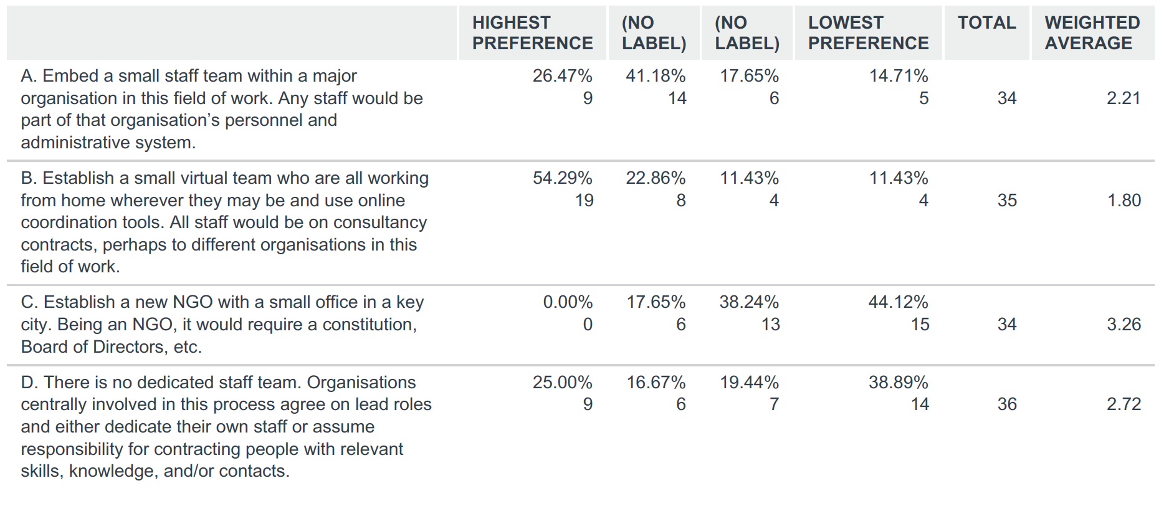

The highest and majority preference was to establish a small virtual team using online coordination tools, with consultancy contracts to one or perhaps a few organisations as the basis of their work arrangement.

FUNDING BASE: What is your preference as the funding base for the mechanism? Choose only one.

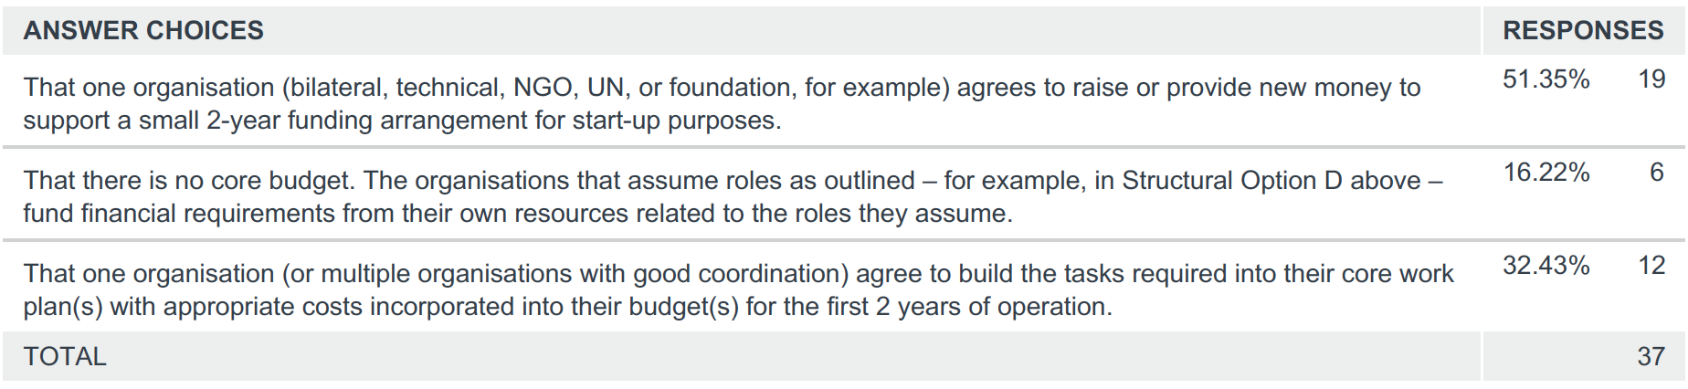

The majority preference was for one organisation to raise or provide new money to support a small 2-year funding arrangement for start-up purposes.

In consideration of these options and the preferences expressed, the following were some of the main themes contributed by participants.

1. There is a need to be pragmatic and realistic in any plans that are made. Funding is challenging and resources are constrained. Therefore, it is neither desirable nor possible to raise large levels of funds in order to commence this process.

2. A process with considerable flexibility in its early stages of development is required.

3. More important than the issues of structure and funding is the question of who is involved in leading this work. Consequently, the emphasis should be on the best people to lead this process, not on a particular pre-formed structure. The initial leadership may be more important than the structural choice.

4. A clear and high priority is to try to ensure representation of Southern people and perspectives.

5. There is a need to work out how to get people who are intimately involved in development action in context at the table rather than telling people how to pursue their development action.

6. The convening of the mechanism process, including in-person meetings, needs to happen on a regular basis in Southern contexts in order to enable and hear perspectives and experiences from around the world

7. It will be important to ensure that this does not look like institution building for its own sake.

8. It was observed that most organisations have a “minimum” bandwidth for partnerships with larger organisations. The big organisations can afford to send people to be part of a process such as this mechanism. Steps and procedures will need to be put into place to ensure that smaller organisations, and their voices and perspectives, are engaged.

9. UNICEF was suggested by many as the best initial “host” organization for any initial contractual and governance relationships, given its exemplary leadership role as one of the key organisations leading the progress made to date.

Alliance meeting
November 29th and 30th, 2017

Paper 7: Name of the Alliance

Task: Decide on the name of the Alliance

Name Group input

This sub-group is still putting the final touches on its proposals. A paper will be shared Monday afternoon. There will be two names suggested.

The process for deciding will be as follows:

- One person will succinctly present the argument for each option.
- A discussion and debate will be held.
- If necessary, a vote will be taken.

Background notes from the consultation and New York All Parties meeting:

Throughout the consultation phase, there were real difficulties identifying a common name for this field of work which in turn has implications for the name of the mechanism. There are 3 factors here:

- This is a principles issue - what lies at the heart of what we all do and so binds us together;
- This is an understanding issue – how do we explain what we do to others;
- This is a practical issue – we cannot expect organisations to change their own naming in response to this work – BBC Media Action will remain as Media; Center for Communication Programs will keep Communication; Soul City will remain the Institute for Social Justice; the Foundation for New Journalism (FNPI) will keep that name; UNICEF will maintain its use of Communication for Development – and these are just a few examples.

While the name of the mechanism is yet to be decided, most participants agreed that an alliance could be the most appropriate option. This alliance is for people, communities, governments, and organisations working across the full range of local, national, and global priorities through strategies that include at least one of the following:

- Communication for development,
- Media for development
- Social change
- Behaviour change
- Entertainment-education
- Social marketing
- Nudge theory
- Stakeholder engagement
- Media development
- Community action
- Issue-focused campaigns
- Community engagement
- Behavioural economics
- Programme communication
- Issue-based networking
- Facilitation of local and national dialogue and debate.

Alliance meeting
November 29th and 30th, 2017

Paper 8: How best to present the Alliance to the broader development community

Open discussion!

